**Da**

**Publish Data To The IBM Cloud**

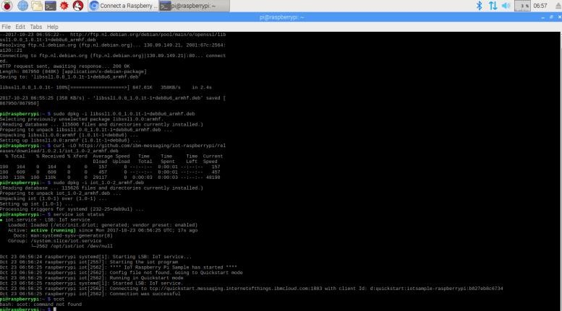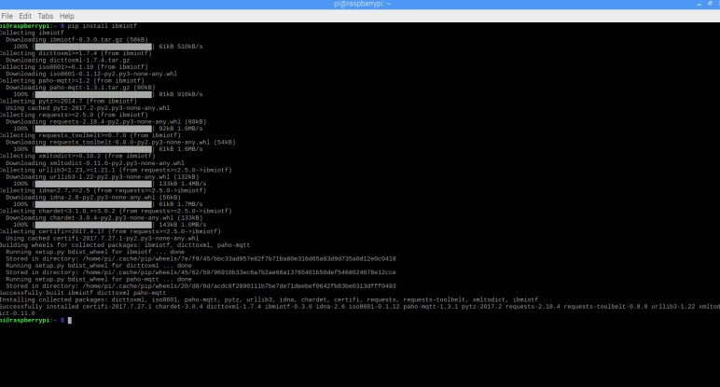

Team

ID

PNT2022TMID41135

Project Name

Project

–

Signs with Smart Connectivity

for Better Road Safety

